**Bomber Field USA * 13917 FM1887*Hempstead, TX 77445**

**Email: bomberfieldtx@gmail.com Mail to**: **15911 Lillija Rd. Houston, Texas 77060**

First Name & Last Name _____________________________

Street Address______________________________________

City ______________________________________________

State _____________________________________________

Postal / Zip Code ____________________________________

Email Address ______________________________________

Phone_____________________________________________

Emergency Contact & phone # _________________________

**AMA Number** _______________________________________

**I understand that I must maintain an active AMA membership to conduct any RC flying activity and that all required waivers must maintained at all times.**

**\*I agree**

**Tell us about yourself.**

**Member**

**sh**

**ip**

**A**

**ppli**

**ca**

**tion**

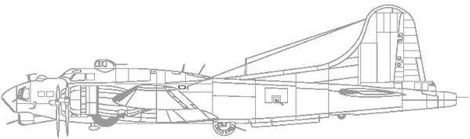

**_____________________________________________________________________________________________________________ _____________________________________________________________________________________________________________**

**I Have AMA waivers and/or certifications.**

**Please provide copies of all AMA waivers and certifications to Bomberfield USA.**

**I hereby agree to comply with all AMA and Bomber Field USA field safety rules for all model aircraft operations at the Bomber Field USA flying site. I further agree to uphold the By-laws and constitution of Bomber Field USA and abide by the standing rules of Bomber Field USA and to any changes or amendments that may be passed by the club during my membership term. I understand that as a condition of membership, my failure to comply with all applicable SAFETY and FLYING RULES and/or failure to conduct myself in a Gentlemanly/Ladylike manner could result in revocation of my membership without refund. I agree to provide, in writing, a written incident report detailing any instance of bodily injury or property damage to both Bomber Field USA and AMA within 30 days of said occurrence. I am aware that model aircraft operation presents hazards and I EXEMPT AND HOLD HARMLESS, Bomber Field USA; it’s OFFICERS AND MEMBERS and Property Owner from all liability including personal injury, property damage, or death caused by my guest’s actions, or me or otherwise on this property.**

**\*By checking this box you understand and agree to the terms above.**

**Signature _______________________________________________________ Circle Membership Type:**

**General $160.00 * Associate $80.00 (over 75 miles from field) Youth $30.00**